A METHODOLOGY FOR MONITORING INVASIVE PLANT MANAGEMENT PROJECTS IN COASTAL HABITATS

Monitoring invasive plant management projects in areas behind the primary dunes where the substrate is more stable may include setting up permanent plots. A very simple monitoring strategy would be to set up a series of permanent plots in which the percent cover of native versus invasive vegetation would be documented. The goal of this monitoring is to have a coarse determination of management success without having to know statistics or being able to identify every plant species in the plots.

Where should I put study plots and how big should they be?
The size and number of the plots will vary with the size and type of the study area. A general rule of plot size is the following:
For grasslands: minimum plot size is 25 to 100 square meters
For shrublands: minimum plot size is 100 to 250 square meters
For forests: minimum plot size is 100 to 500 square meters

Definitions (repeated from above):
Grassland: Grasses, forbs, ferns, and other herbaceous plants dominant, generally forming at least 25% cover. Trees, shrubs, and dwarf-shrubs generally less than 25% cover.
Shrubland: Shrubs generally greater than 0.5 meter tall with individuals or clumps overlapping to not touching, generally forming more than 25% canopy coverage; tree cover generally less than 25%.
Forest and woodland: Trees with their crowns overlapping, generally forming 60- 100% cover Woodlands - Open stands of trees with crowns, not usually touching, generally forming 25-60% cover.

A minimum of three plots should be set up in areas where: the plot is representative of the area as a whole, the plot is uniform in plant composition and structure as well as habitat type – that is: the soil and hydrology within the plot should be uniform (you don’t want a stream running through the plot), there are no major disturbances within the plot (other than the presence of invasive plants), and the plot should not be near the boundary with another vegetation type.

Because the purpose of the plots is to simply monitor the effectiveness of management – that is whether or not the amount of invasive plants is decreasing, there are no control plots. If you wanted to test the efficacy of different treatment types on a particular invasive species, then the experimental design would be quite different.

Each plot corner should be marked using GPS for the plot center and permanent stakes at the corners. Within the plots, all invasive plant species should be listed. Native plants can be lumped together as “Natives” for each vegetation layer (trees, shrubs, grass/herbaceous plants) as the purpose of monitoring is to determine if management to get rid of invasive species is working or not.

After all species and species groups have been listed, enter the total percent cover (cover class) by vegetation layer for each invasive species and for each native vegetation layer (trees, shrubs, grasses/herbaceous plants, indicating dominant plants when possible). Because of layer overlaps, the sum of the percent cover values for all species within each layer may be greater than the total layer coverage. For example, a vine of Asiatic bittersweet twining its way up an oak tree, might have percent cover that is counted twice: once for the invasive vine and again as part of the native tree coverage. Also, percent cover might be canopy cover for some species and ground cover for other species. Management for invasive plants may differ with species which is why percent cover of each invasive species should be documented separately.

Estimating % Cover:
Canopy cover is the portion of the plot covered by the species (or group of species) being surveyed. One way to think of this is to visualize all of the plants pushed together until their canopies touch, and then estimate the overall portion of the plot that this represents. Classify the cover into one of the categories shown below (based on Daubenmire 1959 and reprinted from The California Weed Mapping Handbook: http://wmproto.sonomacreek.net/content/welcome):
Cover Class | Range of Coverage | Midpoint of Range
Trace | < 1% | 0.5%
1 | 1 – 5% | 3.0%
2 | 5 – 25% | 15.0%
3 | 25 – 50% | 37.5%
4 | 50 - 75% | 62.5%
5 | 75 – 95% | 85.0%
6 | 95 – 100% | 97.5%

The graphic below gives a visual image of the amount of cover represented by the midpoint of each of the categories:
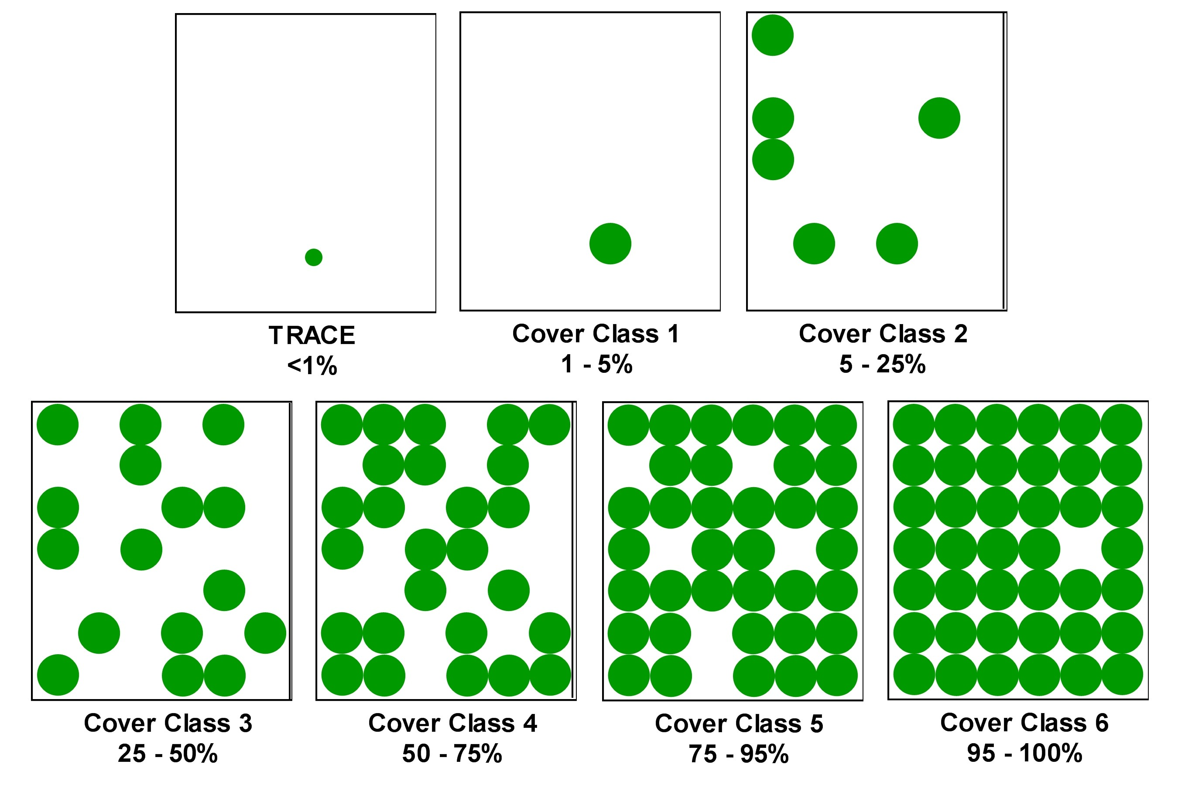

Daubenmire, R. 1959. A canopy-cover method of vegetation analysis. Northwest
Science, 33:43-46.
http://www.vetmed.wsu.edu/org_nws/NWSci%20journal%20articles/1950-1959/1959%20vol%2033/33-1/v33%20p43%20Daubenmire.PDF

Species or Plant Group | Percent Cover (Cover Class)  Year 1 | Percent Cover (Cover Class)  Year 2 | Percent Cover (Cover Class)  Year 3 |  |  | Percent Cover (Cover Class)  Year 4 | Percent Cover (Cover Class)  Year 5
Native Trees
Native Shrubs
Native Herbaceous Plants
Native Vines
Invasive Trees (list individually)
Invasive Shrubs (list individually)
Invasive Herbaceous Plants (list individually)
Invasive Vines (list individually)

Sample the plot prior to doing any management and then on an annual basis for at least 5 years, recognizing that management may be ongoing during this period. For each invasive plant species determine its percent cover within the plot. Seedlings may be difficult to identify so draw a picture or take a photograph and come back and check later in the growing season or place a marker next to the seedling and check the following year. Many invasive plants have large seed banks in the soil, and management of this seed bank should be part of the management strategy, as will resprouting of established plants.

Prior to beginning any restoration or management work on coastal habitats in Connecticut or New York, contact should be made with the Long Island Sound Study Habitat Restoration Coordinators:

Heather Young
New York State Department of Environmental Conservation
Long Island Sound Habitat Restoration Coordinator
205 N. Belle Meade Rd. Suite 1
East Setauket, NY 11733
phone: 631-444-0441
fax: 631-444-0474
hxyoung@gw.dec.state.ny.us

Harry Yamalis
CT Department of Energy and Environmental Protection
Office of Long Island Sound Programs
79 Elm Street
Hartford, CT 06106-5127
Phone: 860-424-3620
Fax: 860-424-4054
harry.yamalis@ct.gov

Other Potential Contacts:
U.S. Fish and Wildlife Service
Southern New England - New York Bight Coastal Program
50 Bend Road
Charlestown, RI 02813
Phone: 401/364-9124
Fax: 401/364-0170 fax
Email: FW5ES_SNENYBCEP@fws.gov

New York Sea Grant
http://www.seagrant.sunysb.edu/articles/t/bringing-science-to-the-shore-since-1971

Connecticut Sea Grant
http://web.uconn.edu/seagrant/

The Nature Conservancy Connecticut
http://www.nature.org/ourinitiatives/regions/northamerica/unitedstates/connecticut/index.htm

The Nature Conservancy New York
http://www.nature.org/ourinitiatives/regions/northamerica/unitedstates/newyork/index.ht

Save the Sound
http://ctenvironment.org/save-the-sound.cfm

Audubon Connecticut
http://ct.audubon.org/

Audubon New York
http://ny.audubon.org/

Connecticut Audubon Society
http://www.ctaudubon.org/

