HABITAT-BASED MANAGEMENT PLANNING
Juliana Barrett, CT Sea Grant and UConn’s NEMO program

Connecticut’s open space lands will come under more, not less, pressure in the future. Pressures such as changes in surrounding land use, habitat fragmentation, invasive and rare species, and climate change will impact these properties. Our hope is that this habitat-based management plan outline will be a useful tool for land trust stewards and town open space managers in the long-term conservation and management of open space in Connecticut.

This outline provides a framework for the documentation of background information and a methodology to determine management actions, based on habitat, needed for the long term conservation of a particular site. This is an opportunity to think about, “How do we want this property to look in 10, 20, even 50 years from now?”

Users of this outline may find that it provides a way to consolidate information that has accumulated about a site – both on paper and in the personal knowledge of site stewards, and may fill in many, if not all, sections. Other users may skip entire sections. There is no right or wrong way to use this outline.

The habitat management planning outline is available online at:
http://clear.uconn.edu/tools/habitats/

The community resource inventory is available
online at: http://nemo.uconn.edu/tools/cri/index.htm

juliana.barrett@uconn.edu

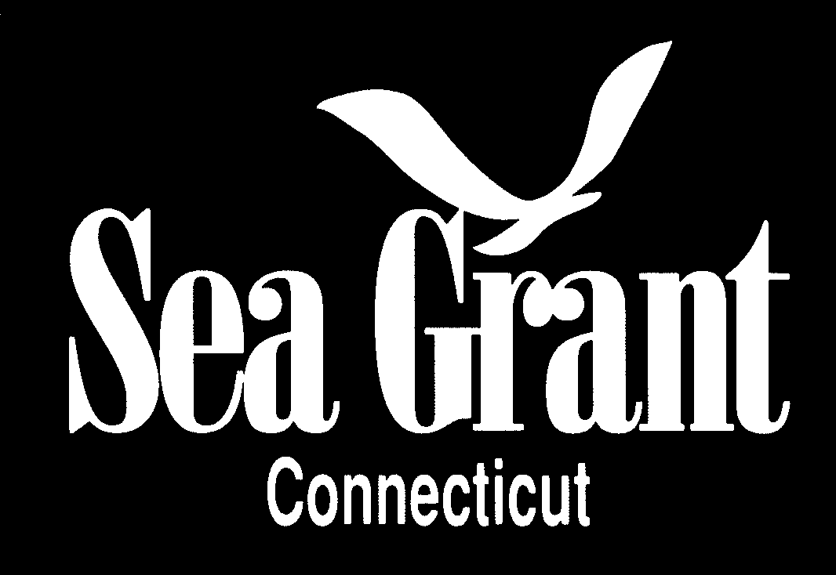



The habitat management
HABITAT-BASED MANAGEMENT PLAN OUTLINE

I. INTRODUCTION of the PLAN

This section provides the overall context for the Plan.

A. Author(s) of plan and Date

B. Purpose of this plan (more detail can be provided in Section II).
Purpose may read something like the following:
The purpose of this plan is to describe how we envision the future condition and public use of Preserve XXX. This plan describes the natural and cultural resources of Preserve XXX and recommends management and restoration actions needed to preserve, protect, and restore the Preserve’s natural habitats and significant species populations, as well as cultural resources. At the same time, public use and enjoyment must be balanced with these actions (or other suitable wording)

C. General property description (more detailed description will be in Section III). (Include a map showing location within the town and access points)

1. Physical characteristics: location, size (acres), general landscape description, special features, access points, existing structures

2. History and background: date of acquisition, history of acquisition, former use(s) and history of site

3. Ownership

4. Deed Restrictions

5. Other use/management restrictions

6. Current management: trail creation/preservation, maintenance, etc. (Keep general – provide details under Section V)

II. GENERAL GOALS OF THE PRESERVE
This section sets the broad goals of the Plan, and provides the foundation for the more detailed recommendations in Section VI. This section should answer the question: Why did you acquire this property?

A. How does this property fit into town/state open space plans or existing open space?

Examples of goals might be:

- Protect and manage a significant tract of undeveloped land
- Protect and/or connect corridors (e.g. riparian, wildlife)

- Protect an area identified in the town as high priority open space

B. What are your goals for public use of the property / Is the property open to the public?
- Provide the public with opportunities for recreational and scenic enjoyment
- Encourage scientific research, monitoring and inventory work
- Provide for environmental education opportunities

III. CHARACTERISTICS OF THE PRESERVE

This section is provided as an overview and does not attempt to detail all the information found in reports and documents prepared by others – list these in the bibliography. Don’t get hung up on every category -- fill in whatever you can (resources are listed under Technical Resources). Our particular emphasis is on Habitats as the most logical way to approach management goals, so we’ve listed that first.

A. Natural Habitats
A habitat is simply the place where an organism lives including both the biotic (living) and abiotic (nonliving) components. The ways to describe habitats are endless. Unless you have access to professional assistance, we recommend that you characterize your Preserve and the habitats of which it is composed using the following four general categories.

1. Forests & Woodlands
Forests - Trees with their crowns overlapping, generally forming 60- 100% cover
Woodlands - Open stands of trees with crowns, not usually touching, generally forming 25-60% cover

2. Shrublands - Shrubs generally greater than 0.5 meter tall with individuals or clumps overlapping to not touching, generally forming more than 25% canopy coverage; tree cover generally less than 25%

3. Grasslands /Meadows - Herbs, graminoids, forbs, and ferns dominant, generally forming at least 25% cover. Trees, shrubs, and dwarf-shrubs generally less than 25% cover

4. Special Habitats: Vernal pools; bedrock ledges, and other special areas can be noted here.

Key references:

Kenney, L.O. and M.R. Burne. 2001. A Field Guide to the Animals of Vernal Pools. Massachusetts Division of Fisheries and Wildlife Natural Heritage & Endangered Species Program & Vernal Pool Association.

Metzler, K.J. and J.P. Barrett. 2006. The Vegetation of Connecticut A Preliminary Classification. State Geological and Natural History Survey of Connecticut. Report of Investigations No. 12. Hartford.

See Appendix A for information on Connecticut’s geology and soils.

B. PLANTS AND WILDLIFE
You don’t need an exhaustive list here, although the more information you have, the better. Think about any special flora and fauna that need consideration. Are there any parts of the Preserve significant for wildlife? For example, birds that use the Preserve during fall migration, or a particularly good trout stream? Is there any plant species worth making note of that might need special management considerations?

Key references:
Local expertise/Local naturalists

Connecticut’s Comprehensive Wildlife Conservation Strategy: http://www.ct.gov/dep/cwp/view.asp?a=2723&q=329520&depNav_GID=1719

Connecticut Botanical Society
http://www.ct-botanical-society.org/

Connecticut Audubon Society
http://www.ctaudubon.org/

For general locations of state and federally listed Endangered, Threatened, and Special Concern species, and significant natural communities, there is a statewide data layer at 1:24,000 scale that can be accessed through the NEMO Community Resource Inventory http://clear.uconn.edu/projects/cri/cri_online/06_unique.asp?

C. CULTURAL RESOURCES

While a parcel of land may have been acquired primarily for its natural resources, there may be other resources that are not natural in origin, but worthy of protection and maintenance within a preserve. Examples could include old farm fields and pastures, stone walls, specimen trees, barns or planted areas.

Key references:
Local expertise

Stonewalls:
http://www.stonewall.uconn.edu/Resources.htm

Office of the Connecticut State Archeologist
http://www.cac.uconn.edu/osa.html

IV. EXISTING ACTIVITIES IN THE PRESERVE (recreational, educational and research)

This section describes the uses of your preserve, and thus provides the human side of the equation that your management recommendations need to consider. You may want to note if permission (written or verbal) is needed for any of these activities. Note that management activities are not described here as the management issues have not yet been described (Section V).

A. Current Recreational Uses (passive/active)
1. Allowed uses
- Are boundaries clearly posted?
- Is the preserve open to the public, and if so, when?
- If open to the public, are allowed uses passive recreation, active recreation, or both?

a. Passive Recreation: e.g. hiking, birding, dog walking, boating i. Trails
What activities are allowed on existing trails

ii. No trails (hiking. etc. through woods allowed) It could be that no trails exist or are planned for this property

b. Active Recreation: e.g. boating/fishing, dirt bike riding, horseback riding, sports activities, hunting, rock climbing, beach activities
i. Trails
- What activities are allowed on existing trails?

ii. No trails
- Are any active recreational activities allowed in areas without trails (e.g. rock climbing)?

2. Recreational uses that are NOT allowed (Be specific)

B. Research
- Is research allowed on the Preserve?
- Do you want to encourage research? If so, develop a list of research/management questions (Section VIII), the answers to which would aid in management of the Preserve.

See Appendix B for language on allowing Species Collections.

C. Forestry
- Are there current forestry activities?

D. Education
- Is the Preserve open for educational uses such as for field trips (K-12, university)?

V. MANAGEMENT ISSUES, CURRENT MANAGEMENT ACTIVITIES, and PLANNED MANAGEMENT ACTIVITIES
You’ve described the natural and cultural characteristics of the property, and how it is being used. This section is the place to discuss particular problems or concerns, and how you envision the future of the Preserve - before you go on to detail your management recommendations in section VI.

A. Natural Habitats/Plants/Wildlife
For each issue that you want to describe, include the following:
1. “Natural Habitat, Plant or Animal” (be specific)
a. Existing site condition
b. Current management activities, if any
c. Planned or desired future condition

(listed below are examples of issues that could be addressed here for specific natural habitats or species) See Appendix C for other ideas on Management provisions.
- Invasive Species (plant and/or animal) – be specific as to what habitats are impacted and what the invasive species are
- Erosion (e.g. stream or riverbank erosion)
- Restoration Projects (examples: tidal marsh restoration, fish ways)

(Appendix C contains more examples of issues that might need to be addressed as well as management provisions.)

B. Cultural Resources (You’re probably not going to add new cultural resources to the Preserve, but you may want to maintain and manage existing ones. For example, a field or meadow should be mown on a regular basis; a stonewall needs to be rebuilt, or an existing structure on the property needs to be rebuilt for storage of equipment)
1. “Cultural Resource” (be specific)
a. Existing site condition
b. Current management activities, if any (e.g. Pasture is mown annually to keep shrubs and saplings from overtaking herbaceous plants)
c. Planned or desired future condition

C. Recreational/Educational Activities
1. Boundaries – Are all boundaries clearly posted?
2. Existing Trails (e.g. The existing trail system needs regular maintenance; Are there problems with overuse, erosion; Should some trails be closed, etc?)
3. Planned or desired trails, parking areas, etc.
4. Planned educational activities (e.g. nature trail guide)

VI. MANAGEMENT RECOMMENDATIONS and PLANNED ACTIVITIES (to achieve a desired future condition)

This is where the rubber meets the road. Be as specific as you can. For the most part, the most effective recommendations specify not only what needs to be done, but who will do it, when, and how it will get done (cost, volunteer power, etc.)

A. Natural Habitats/Plants/Wildlife

For each issue described in section V, what steps will be taken to achieve the desired future condition, in addition to any current management activities that are ongoing?

(Also, consider alternatives. If the desired future condition in not attainable in the short term, what is an acceptable future condition? Often eradication of invasive plants, while desirable, is not possible. So the goal might be to keep invasive plants under control, and possibly to focus on eradication within a significant habitat described in Section III.)

Example:
FOREST: Several invasive plant species were found in the forest borders:

Alliaria petiolata (Garlic mustard) and Euphorbia cyparissias (Cypress spurge)

– infestation heavy and will require several years of hand pulling.
Work party of volunteers to hand pull scheduled for May‘08
Estimated total time for hand pulling in the first year (08) is 50 hours and should decrease in subsequent years. Area will be monitored annually by Preserve Steward to determine need for continued management.
Plants must be bagged and disposed of properly.

B. Cultural Resources
Example:
FIELD: One of the cultural habitats of the Preserve a 12 acre field (formerly pasture). In order to maintain this field it must be mown at least every 3 to 4 years to control tree and shrub growth. Mowing will be done by XXX at a cost of XXX. Mowing will not take place between April 15 and August 14 to minimize impacts to wildlife. An annual survey will be made by the Preserve Steward to determine if mowing should occur more frequently, or if invasive plants are becoming a problem.

C. Recreational/Educational uses
1. Existing trails – annual maintenance conducted by Preserve Steward

2. New trails If new trails are desired, plan them out (using GPS if available) to see how they would fit with the existing trail system.
3. Research and Education (e.g. nature trail guide, possibly with signage)

VII. IMPLEMENTATION SCHEDULE Each activity described in Sections V (current activities) and VI (recommended activities) should have its own table with an implementation schedule.
Be sure that the activities recommended here relate back to the General Goals of the Preserve (Section II).

A. Current ongoing activities
B. Recommended activities

ACTION | WHO | WHEN (initiation and completion dates) | RESOURCES | EVALUTION/MONITORING

VIII. Management Questions
Examples:
What is the best way to control garlic mustard (or any other invasive species)?
How can we control streamside erosion?
What should we do to encourage bird or small mammal populations?
APPENDICES

Appendix A.

Bedrock geology & soils

Bedrock is the solid material that underlies the soil or other unconsolidated material of the earth. Bedrock geology can have a great influence on the nature of your preserve. The DEP 1985 Bedrock Geological Map of Connecticut (1:50,000) can be accessed at the website below.

Key reference:

http://ct.gov/dep/cwp/view.asp?a=2698&q=323074&depNav_GID=1707

http://www.tmsc.org/geology/bedrock/quadlist.htm

Soils are the unconsolidated mineral or organic material on the earth’s surface, and are one of the primary determinants of the vegetation on your property. Soils data can be accessed through the USDA Natural Resources Conservation Service website (below), or for simplified wetland and farmland soils, you can go to the NEMO Online Community Resource Inventory (CRI) website:

Key references:
http://websoilsurvey.nrcs.usda.gov/app/
http://nemo.uconn.edu/tools/cri/index.htm

Rodgers, J. 1985. Bedrock Geological Map of Connecticut. CT Geological and Natural History Survey, CT Dept. of Environmental Protection in cooperation with U.S. Dept. of the Interior U.S. Geological Survey. Hartford, CT.
Stone, J. R., J. P. Schafer, E. H. London, W. B. Thompson. 1992. Surficial Materials Map of Connecticut. U.S. Dept. of the Interior U.S. Geological Survey.

Appendix B.
Species Collections
Collection of plants, animals, minerals, water, and soil in the Preserve is not allowed unless specific permission is sought through an education, collection, or research permit. Permission may be granted based on the applicant’s demonstration of how collection will contribute to and aid an education or research effort. In no case shall the collection of plants and animals, other than invasive species, exceed the quantity necessary to maintain a healthy and viable population of that species.

Appendix C.
Management Provisions:
(Here are several provisions to consider with possible wording. Taylor to fit your needs and goals.)

Structures
No roads or permanent structures will be constructed in the Preserve. The placement of a temporary structure(s) may be approved as part of a research permit, provided it is removed when not in active use. In order for a structure to be considered in active use, it must be used at least once during a XX day period.

Fire Control
No fires shall be started in the Preserve unless it is a prescribed fire undertaken for a specific purpose identified in this Plan. Every effort shall be made to prevent fires from spreading into the Preserve. All uncontrolled fires shall be brought under control as quickly as possible.

Natural Disasters
In the event of a natural disaster, such as fire, flood, wind, disease, etc., any restoration activity will be limited to that work necessary to prevent further damage to resources. As an example, if a windstorm takes down a large number of trees, will you just leave the area alone, harvest the timber, or some combination?)

Signage and Markers
Location markers shall be placed delineating the boundaries of the Preserve.

Vegetation Management
Vegetation management (mowing, brush trimming, herbicide use, etc.) may be conducted within the Preserve. Any vegetation management necessary to maintain a trail shall be performed in a non-aggressive manner, aimed at maintaining a natural appearance.

Wildlife Population Control
Population control may be exercised whenever wild or feral fauna reach population levels that are adversely impacting Preserve resources.
(e.g. white tail deer, beaver)

Invasive Plant Species
Opportunistic plant species (native and non-native) could become established, outcompeting existing vegetation in the Preserve. If this condition develops to the extent that it threatens the quality and value of the Preserve, a control program may be developed to reverse the spread of invasive plant species. If a control program involves a regulated activity, all permits must be obtained.

Encroachments
There will be no encroachment of structures, easements, rights of way or land uses on the Preserve except for those specified in this management plan. No other encroachments shall be allowed to continue or become established.

Erosion Control (Consider natural erosion versus erosion from human activities)
Natural erosion shall not be controlled. Erosion and soil deposition affecting the Preserve due to past or present activities by people may be controlled.

Removal of or Introduction of Objects
Except as is provided for in this Management Plan, there shall be no introduction to, removal from, or consumptive use of any material, product, object, or animal in the Preserve. Prohibited activities include, but are not limited to, gathering of firewood or other plant or animal products and dumping, burying, or spreading of garbage, trash, or other materials.

Appendix D.
LIST OF CONTACTS OR POTENTIAL PARTNERS

Appendix E.
BIBLIOGRAPHY AND PUBLICATIONS PERTAINING TO THE PRESERVE

Appendix F.
TECHNICAL RESOURCES (This is not an exhaustive list, rather a selection of possible resources that are available online)
Community Resource Inventory Online (CRI)
http://clear.uconn.edu/projects/cri/index.htm

The NEMO Program’s Tools and Resources
http://nemo.uconn.edu/tools/publications.htm

UConn Clear website
http://clear.uconn.edu/

aerials and other maps
http://map.live.com

Bedrock geology by quadrangle
http://www.tmsc.org/geology/bedrock/quadlist.htm

Soils maps (in addition to the CRI)
http://websoilsurvey.nrcs.usda.gov/app/

University of Connecticut Cooperative Extension Forestry
http://www.canr.uconn.edu/ces/forest/

Invasive plant species (includes Connecticut Invasive Plant List and fact sheets)
http://www.hort.uconn.edu/CIPWG/

Aquatic nuisance species
http://www.seagrant.uconn.edu/ans.htm

Connecticut Botanical Society
http://www.ct-botanical-society.org/

Connecticut Audubon Society
http://www.ctaudubon.org/

Connecticut Master Gardeners
http://www.ctmga.org/

Managing Grasslands, Shrubland and Young Forest for Wildlife
A guide for the Northeast 2006
http://www.wildlife.state.nh.us/Wildlife/Northeast_Hab_Mgt_Guide.htm

Wetlands of Connecticut
Pdf will be available soon through the CT DEP website

Appendix G.
POTENTIAL FUNDING SOURCES (This is not an exhaustive list, rather several potential source of funding.)
CT DEP Grants to Municipalities Program for control of invasive Plants
http://www.ct.gov/dep/cwp/view.asp?a=2702&q=425512&depNav_GID=1641

NRCS (Natural Resources Conservation Service) WHIP (Wildlife Habitat Incentive Program) cost share agreements http://www.ct.nrcs.usda.gov/
http://www.nrcs.usda.gov/programs/whip/

Long Island Sound Study Futures Fund (habitat restoration) http://www.nfwf.org/AM/Template.cfm?Section=Home&Template=/CM/ContentDisplay.cfm&ContentID=3896

Land Trust Alliance
http://www.lta.org/resources/index.html

Long Island Sound License Plate Fund http://www.ct.gov/dep/cwp/view.asp?A=2705&Q=323786

NU Community Investment Grants
http://www.cl-p.com/community/partners/cinvest.asp

National Fish and Wildlife Foundation http://www.nfwf.org/AM/Template.cfm?Section=Grants

Check into local and regional funding sources: such as town funds (through the Conservation Commission budget, special project funding, or etc.) as well as local and regional foundations.

